

**Mawlana Bhashani Science and Technology University**

**Lab-Report**

Report No:08

Course code: ICT-3110

Course title: Operating System Lab

Date of Performance:08/09/2020

Date of Submission:10/09/2020

**Submitted by Submitted To**

Nazrul Islam

Assistant Professor

Dept. of ICT

MBSTU.

Name:Md Asikur Rahman

ID:IT-18025

3rd  year 1st semester

Session: 2017-2018

Dept. of ICT

MBSTU.

# Experiment no : 08

# Experiment Name : Implementation of SJF Scheduling Algorithm

# Theory:

SJF is a scheduling algorithm that assigns to each process the length of its next CPU burst/execution time. CPU is then given to the process with the minimal CPU burst from the waiting queue. SJF is provably optimal, in that for a given set of processes and their CPU bursts/execution times it gives the least average waiting time for each process. The average waiting time for a process is defined by:

S=(W1+W2+...+Wn)/n [1], where Wk=Wk-1+tk-1 [2] is the waiting time for a kth process and ti is the execution time/length of next CPU burst of the ith process; 1<= k, i <=n (actually, the execution time of the last process in the queue, tn, does not affect any waiting times), and W0=0.

If we replace [2] into [1], we get: WS=((n-1)t1+(n-2)t2+...+(n-k)tk+... +tn-1)/n [3]

Now let us suppose that we have an arbitrary set of *n* CPU bursts, { t1, t2, ... , tn }.

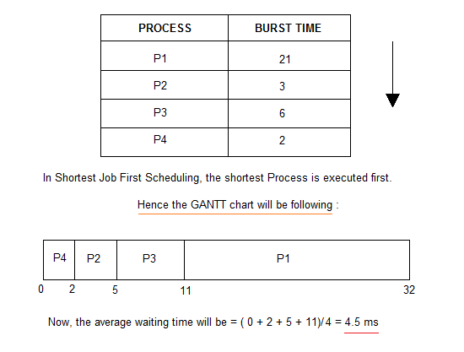

# Working Procedure:

Coding implementation with python…

*'''  
Created by asik  
date:02/09/2020  
  
'''***class** SJF:  
  
 **def** processData(self, no_of_processes):  
 process_data = []  
 **for** i **in** range(no_of_processes):  
 temporary = []  
 process_id = int(input(**"Enter Process ID: "**))  
  
 arrival_time = int(input(**f"Enter Arrival Time for Process {process_id}: "**))  
  
 burst_time = int(input(**f"Enter Burst Time for Process {process_id}: "**))  
 temporary.extend([process_id, arrival_time, burst_time, 0])  
 **'''  
 '0' is the state of the process. 0 means not executed and 1 means execution complete  
 '''** process_data.append(temporary)  
 SJF.schedulingProcess(self, process_data)  
  
 **def** schedulingProcess(self, process_data):  
 start_time = []  
 exit_time = []  
 s_time = 0  
 process_data.sort(key=**lambda** x: x[1])  
 **'''  
 Sort processes according to the Arrival Time  
 '''  
 for** i **in** range(len(process_data)):  
 ready_queue = []  
 temp = []  
 normal_queue = []  
  
 **for** j **in** range(len(process_data)):  
 **if** (process_data[j][1] <= s_time) **and** (process_data[j][3] == 0):  
 temp.extend([process_data[j][0], process_data[j][1], process_data[j][2]])  
 ready_queue.append(temp)  
 temp = []  
 **elif** process_data[j][3] == 0:  
 temp.extend([process_data[j][0], process_data[j][1], process_data[j][2]])  
 normal_queue.append(temp)  
 temp = []  
  
 **if** len(ready_queue) != 0:  
 ready_queue.sort(key=**lambda** x: x[2])  
 **'''  
 Sort the processes according to the Burst Time  
 '''** start_time.append(s_time)  
 s_time = s_time + ready_queue[0][2]  
 e_time = s_time  
 exit_time.append(e_time)  
 **for** k **in** range(len(process_data)):  
 **if** process_data[k][0] == ready_queue[0][0]:  
 **break** process_data[k][3] = 1  
 process_data[k].append(e_time)  
  
 **elif** len(ready_queue) == 0:  
 **if** s_time < normal_queue[0][1]:  
 s_time = normal_queue[0][1]  
 start_time.append(s_time)  
 s_time = s_time + normal_queue[0][2]  
 e_time = s_time  
 exit_time.append(e_time)  
 **for** k **in** range(len(process_data)):  
 **if** process_data[k][0] == normal_queue[0][0]:  
 **break** process_data[k][3] = 1  
 process_data[k].append(e_time)  
  
 t_time = SJF.calculateTurnaroundTime(self, process_data)  
 w_time = SJF.calculateWaitingTime(self, process_data)  
 SJF.printData(self, process_data, t_time, w_time)  
  
  
 **def** calculateTurnaroundTime(self, process_data):  
 total_turnaround_time = 0  
 **for** i **in** range(len(process_data)):  
 turnaround_time = process_data[i][4] - process_data[i][1]  
 **'''  
 turnaround_time = completion_time - arrival_time  
 '''** total_turnaround_time = total_turnaround_time + turnaround_time  
 process_data[i].append(turnaround_time)  
 average_turnaround_time = total_turnaround_time / len(process_data)  
 **'''  
 average_turnaround_time = total_turnaround_time / no_of_processes  
 '''  
 return** average_turnaround_time  
  
  
 **def** calculateWaitingTime(self, process_data):  
 total_waiting_time = 0  
 **for** i **in** range(len(process_data)):  
 waiting_time = process_data[i][5] - process_data[i][2]  
 **'''  
 waiting_time = turnaround_time - burst_time  
 '''** total_waiting_time = total_waiting_time + waiting_time  
 process_data[i].append(waiting_time)  
 average_waiting_time = total_waiting_time / len(process_data)  
 **'''  
 average_waiting_time = total_waiting_time / no_of_processes  
 '''  
 return** average_waiting_time  
  
  
 **def** printData(self, process_data, average_turnaround_time, average_waiting_time):  
 process_data.sort(key=**lambda** x: x[0])  
 **'''  
 Sort processes according to the Process ID  
 '''** print(**"Process_ID Arrival_Time Burst_Time Completed Completion_Time Turnaround_Time Waiting_Time"**)  
  
 **for** i **in** range(len(process_data)):  
 **for** j **in** range(len(process_data[i])):  
  
 print(process_data[i][j], end=**" "**)  
 print()  
  
 print(**f'Average Turnaround Time: {average_turnaround_time}'**)  
  
 print(**f'Average Waiting Time: {average_waiting_time}'**)  
  
  
**if** __name__ == **"__main__"**:  
 no_of_processes = int(input(**"Enter number of processes: "**))  
 sjf = SJF()  
 sjf.processData(no_of_processes)

# Output:

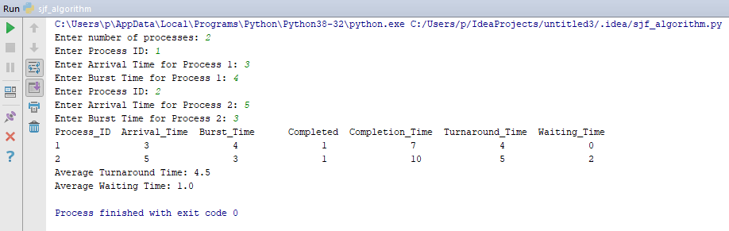

# Discussion:

1.SJF method gives the lowest average waiting time for a specific set of processes.

2.It is appropriate for the jobs running in batch, where run times are known in advance.

3.For the batch system of long-term scheduling, a burst time estimate can be obtained from the job description.